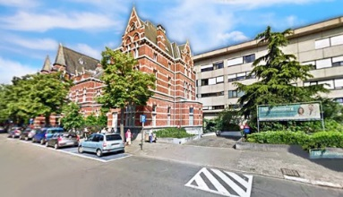 ETCA – ISGE

Masterclass Hysteroscopy & Ultrasound – Building Bridges
Friday May 17 and Saturday May 18, 2019
ETCA – ZNA Campus Stuivenberg – Antwerp - Belgium

SCIENTIFIC PROGRAMME

Course directors:
Bart De Vree Bruno van Herendael
Wouter Froyman Thierry Van Den Bosch

Invited faculty:
J. Bosteels
Ch. De Bruyn
B. De Vree
M. Francx
W. Froyman
T. Hamerlynck
E. Roets
B. Tas
S. Van Calenbergh
T. Van Den Bosch
B. van Herendael
D. Van Schoubroeck
R. Vanspauwen

Friday, May 17

9:00 Welcome/registration

9:40 Introduction

10:00 What’s new in gynaecological ultrasound - W. Froyman

10:20 What’s new in hysteroscopic instrumentation - B. van Herendael

10:40 Case Report (fibroid) - Ch. De Bruyn

11:00 Confrontation: pre-op assessment of fibroids before hysteroscopic treatment
- Hysteroscopy - B. De Vree
- Ultrasound - W. Froyman

11:45 State of the art:
Evaluation of the pre-operative sarcoma risk - T. Van Den Bosch

12:15 Discussion

12:45 Lunch

14:00 – 17:00 Hands-on ultrasound and operative hysteroscopy

Saturday, May 18

9:00 Welcome

9:30 State of the art:
Hysteroscopic myomectomy, the evolution : past, present and future -
B. van Herendael

10:00 Case Report (endometrium/polyps) - Ch. De Bruyn

10:15 Confrontation: diagnosis and treatment in the patient with abnormal uterine bleeding (endometrium/polyps)
- Hysteroscopy – S. Van Calenbergh
- Ultrasound – T. Van Den Bosch

11:00 State of the art: New approaches in the diagnosis of uterine malformations
D. Van Schoubroeck

11:30 A new topic in hysteroscopy: niche or cesarean scar defect – B. De Vree

11:50 Confrontation: New modalities in diagnosis and treatment of placental remnants
- Ultrasound – E. Roets
- Hysteroscopy – T. Hamerlynck

12:20 Discussion

12:45 Lunch

14:00 – 17:00 Hands-on ultrasound and operative hysteroscopy

Our sponsors

