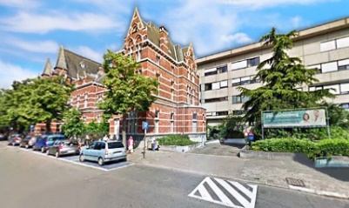 ETCA – ISGE
Masterclass Hysteroscopy & Ultrasound – Building Bridges
Friday May 17 and Saturday May 18, 2019
ETCA – ZNA Campus Stuivenberg – Antwerp - Belgium

Registration
For registration, payment details and all further questions regarding this Masterclass Hysteroscopy & Ultrasound – Building Bridges please contact info@etca.be .
Course fee:
- € 270 regular rate
- € 240 VVOG or ISGE members
- € 170 registrars (limited number - proof of residency required)

