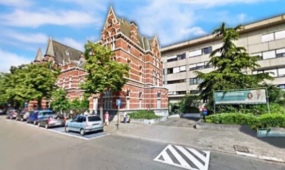 ETCA – ISGE 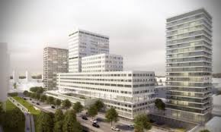
Masterclass Hysteroscopy & Ultrasound – Building Bridges
Friday May 17 and Saturday May 18, 2019
ETCA – ZNA Campus Stuivenberg – Antwerp - Belgium

Welcome letter,

Dear colleagues and friends,
We are happy to invite you to our joint ETCA – ISGE ‘Masterclass Hysteroscopy & Ultrasound – Building Bridges’ on 17 – 18 May 2019 in Antwerp – Belgium.
2019 is the last year that the ETCA (Endoscopic Training Center Antwerp) will be housed in the Stuivenberg hospital.
In 2020 the move to the new CADIX hospital is on the program. That is why this 'Masterclass' in the old buildings of the Stuivenberg hospital is a kind of 'end of an era' ...
It is clear that when we aim to perform the most appropriate and safe surgery the hysteroscopist needs the best possible pre-operative diagnosis… coming from diagnostic hysteroscopy and, more and more, from high quality ultrasound imaging.
In this Masterclass we will focus both on the newest developments in hysteroscopy and the most up-to-date novelties in the field of gynaecological ultrasound.
Friday and Saturday morning we will have state of the art lectures on actual ‘hot topics’ with many opportunities for interaction with the experts.
Both Friday and Saturday afternoon are entirely dedicated to hands-on / practical exercises.
A range of ‘nearly live’ hysteroscopic procedures can be practiced on the Karl Storz Virtual Reality Simulator for Gynecology. Furthermore the training in hysteroscopy includes polyp and myoma resection with bipolar resectoscope and with Bigatti shaver.
The ultrasound practical session uses two Volutracer O.P.U.S. transvaginal simulators. It is an ultrasound learning system with real ultrasound cases; trainees scan the given cases as if scanning the actual patient.
Also several high-end ultrasound machines are present and are commented by the expert instructors.

Number of participants: 20 + 4 registrars
Course language: English
CME credits have been asked for this event

Looking forward to meeting you in Antwerp,
Bart De Vree Bruno van Herendael
Wouter Froyman Thierry Van Den Bosch

Our sponsors

